**TASK 3: SQL for Data Analysis**

1. **Select**

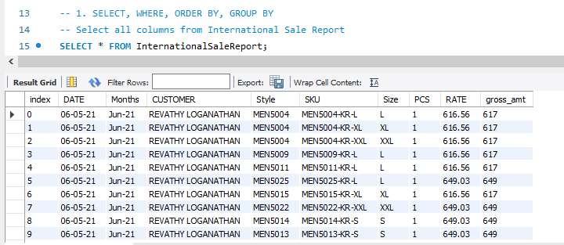

1. **Where**

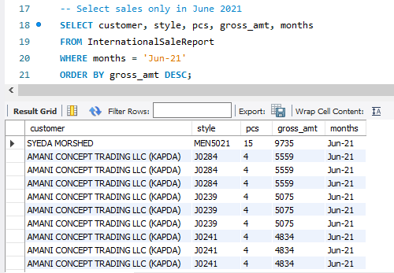

1. **Group**

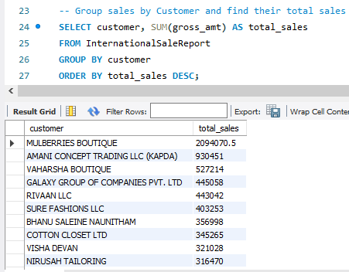

1. **Joins**
2. Inner Join

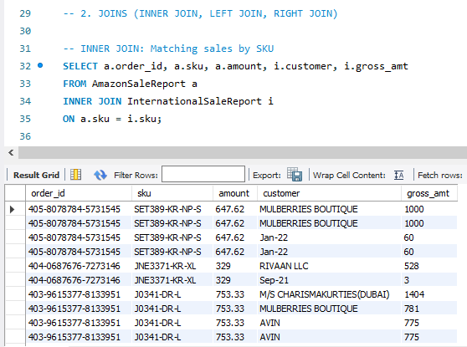

1. Left Join

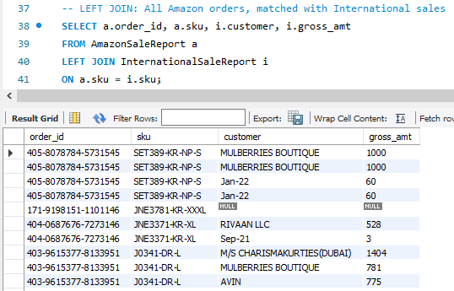

1. Right Join

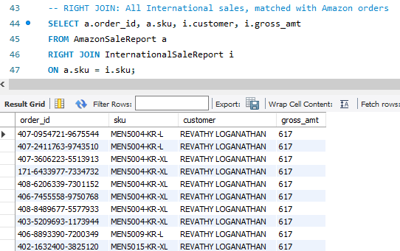

1. **SubQueries**

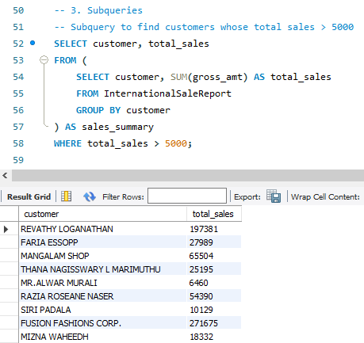

1. **Aggregation Function**
2. Sum()

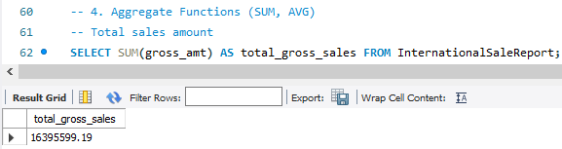

1. Avg()

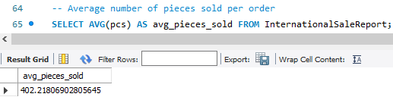

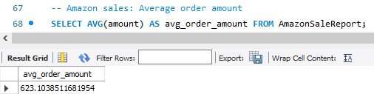

1. **Views**

-- Create a view for high-value international sales

CREATE VIEW HighValueInternationalSales AS

SELECT customer, style, pcs, gross_amt

FROM InternationalSaleReport

WHERE gross_amt > 1000;



-- Create a view for Amazon Delivered Orders

CREATE VIEW AmazonDeliveredOrders AS

SELECT order_id, sku, amount

FROM AmazonSaleReport

WHERE status LIKE '%Delivered%';



1. **Indexes (to speed up queries)**

-- Index on SKU to speed up JOINs

CREATE INDEX idx_sku_international ON InternationalSaleReport(sku(50));



-- Index on Amazon order date for faster date-based queries

CREATE INDEX idx_order_date_amazon ON AmazonSaleReport(date(20));

